Average Weather
 | Normandy, France |  | Venice, Italy
 | (max/min ˚F) | Avg Precipitation | (max/min ˚F) | Avg Precipitation
January | 44˚/33˚ | 2.6 inches | 44˚/33˚ | 2.3 inches
February | 46˚/35˚ | 2.1 inches | 46˚/35˚ | 2.1 inches
March | 51˚/37˚ | 1.7 inches | 51˚/37˚ | 2.3 inches
April | 55˚/41˚ | 1.8 inches | 55˚/41˚ | 2.5 inches
May | 62˚/46˚ | 2.1 inches | 62˚/46˚ | 2.7 inches
June | 68˚/50˚ | 1.7 inches | 68˚/50˚ | 3.0 inches
July | 71˚/53˚ | 1.9 inches | 71˚/53˚ | 2.5 inches
August | 71˚/53˚ | 2.2 inches | 71˚/53˚ | 3.3 inches
September | 68˚/51˚ | 2.5 inches | 68˚/51˚ | 2.6 inches
October | 59˚/40˚ | 2.8 inches | 59˚/40˚ | 2.7 inches
November | 51˚/40˚ | 2.9 inches | 51˚/40˚ | 3.4 inches
December | 46˚/35˚ | 2.3 inches | 46˚/35˚ | 2.1 inches
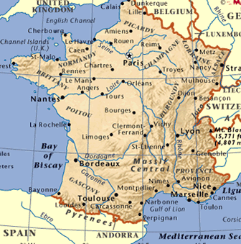
Normandy, France climate information
Normandy is on the west coast of France and has a warm climate.
Good levels of rain mean that the countryside is green but there
are usually more sunny days than cloudy or rainy days. Due to its
northern latitude and coastal position, the weather does not get
to the high temperatures as seen elsewhere in France. Weather can
be unpredictable. However occasional days reaching 80˚ F are not
unusual in the summer and the winter months are relatively mild.
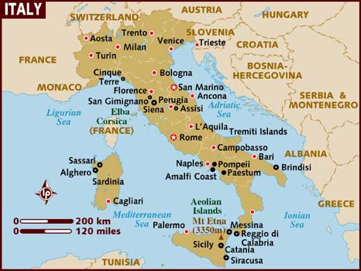
Venice, Italy climate information
In summer, the northern parts of Italy are warm with occasional rainfall,
but winter conditions in Venice are dominated by cold, damp and fog. Being
located in North-East Italy, the climate in Venice changes dramatically
throughout the year. In the winter the temperature can drop below freezing,
while in the summer the temperatures can rise to 35C/96F. As might
be expected from its canals, the humidity remains high all year round.
Because it is surrounded by water, in Venice, cooler temperatures feel colder
and the warmer temperatures hotter.
Sample Weather Report
WEDNESDAY NIGHT: Mostly cloudy skies this evening then clearing overnight and cooler and also less humid. Lows in the mid 40s-50. We had a cold front move through the area today. This front brought the clouds and rain with only a few hundredths of an inch seen across the area. A second front will be dry with no rain and no cloud cover but it does bring a cooler and drier air mass into the area for Friday. Winds tonight will be variable and light.
THURSDAY: Sunny, breezy and less humid. Highs in upper 70s. The next cold front comes in late this afternoon. Ahead of the front will be bright and breezy but once the front passes it will be cooler and less humid. Wind: W at 15-25 m.p.h.

