Soil Texture
Make observations about each type of soil. How are they similar? Different? Use your eyes and sense of touch to make observations about physical properties, texture, color, consistency, and organic matter.
Sand
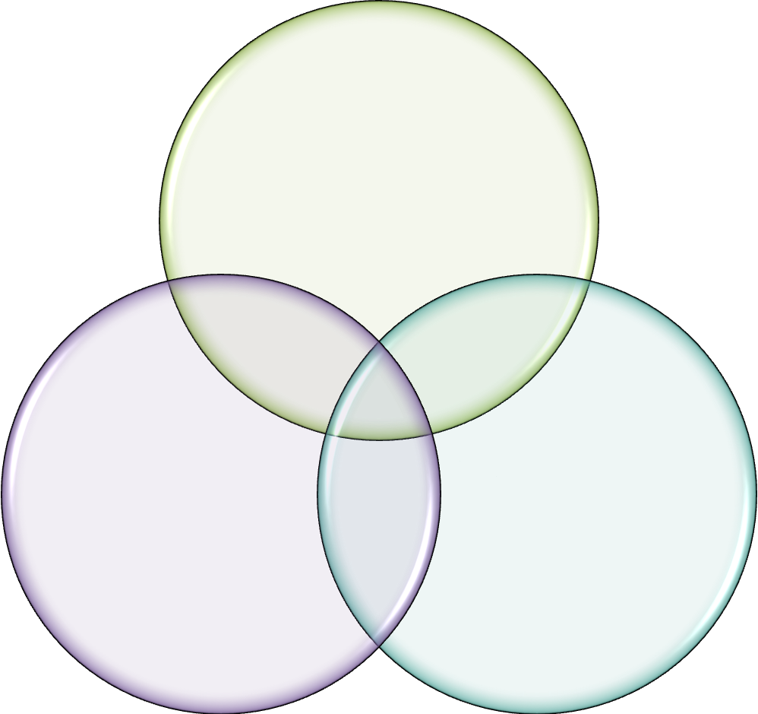

Silt
Clay

Using Materials from the Earth to Create Art
Use your comparisons of the sand, silt, and clay to evaluate each type of soil to be used for art making. Write a short paragraph describing which soil texture you believe would be the best to use for creating ceramic art. Use your observations to analyze the soil and defend your choice.
_____________________________________________________________________________________________________________________________________________________________________________________________________________________________________________________________________________________________________________________________________________________________________________________________________________________________________________________________________________________________________________________________________________________________________________________________________________________________________________________________________________________________________________________________________________________________________________________________________________________________________________________________________________________________________________________________________________________________________________________________________________________________________________

