
www.artnc.org

Movement Photography

Writer: Elizabeth Nida
Grade Level: Pre-K
Related Big Picture Concepts: Movement
Subject Areas: Visual Arts, Dance, Science, Language Arts
Duration: 30 min.

Essential Question: How do our bodies move?

Abstract: This lesson will focus on students using a child-friendly digital camera to capture images of their peers moving.

Pre-K content is made possible by the support of:

Focus Work of Art:
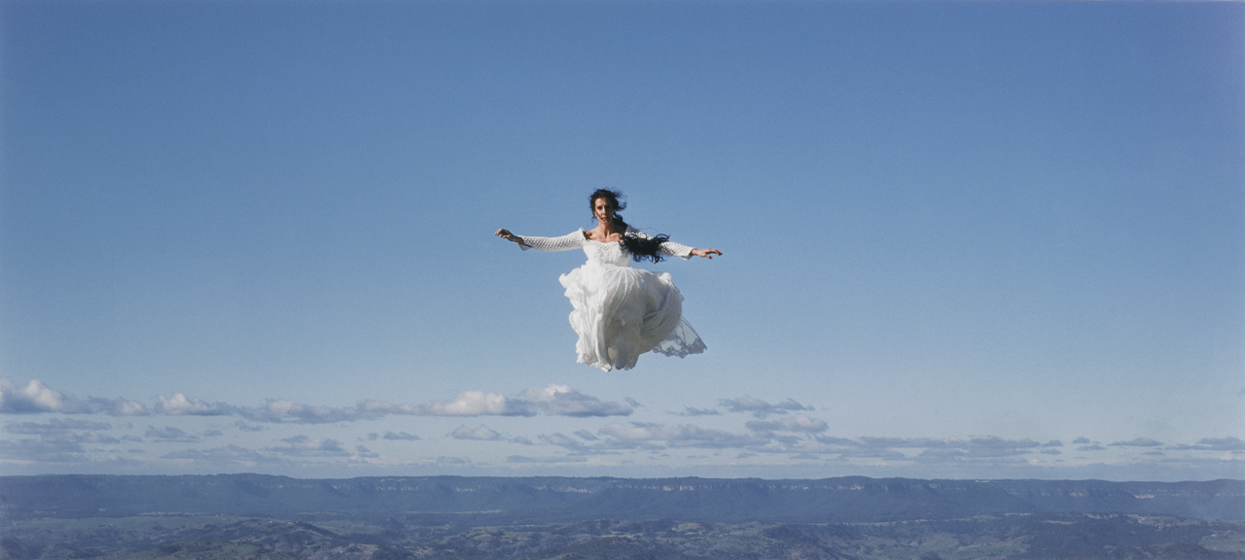
Rosemary Laing, Australian, flight research #5, circa 1999, chromogenic print, 42 3/8 x 94 ¼ in., Purchased with funds from Charles Babcock and Dr. and Mrs. Lunsford Long, by exchange, 2003

North Carolina Standards Correlations
Cognitive Development: CD-5, CD-15
Language Development and Communication: LCD-7

Student Learning Objectives
1. Students will describe and engage in a variety of creative movements.
2. Students will practice using a digital camera safely to capture images of movement.

Activities

Introduction/ Warm-Up

- Begin by asking students to describe their experiences using a camera.
- Introduce the image of flight research #5. Ask students to describe what they see when looking at this photograph. Share the title of the photograph with the students. Why do you think it is called flight research #5? What title would they give it?
- Tell the students they are going to use a camera to take pictures of their friends moving in different ways. Brainstorm a list of ways the students can move (ex. jump, twirl, hop, skip, crawl, roll, etc.). Tell them they will work in small groups to photograph each other moving creatively.
- Model how to use the camera safely, and demonstrate taking photographs of a child or adult moving creatively.
- Divide students into small groups to begin taking photographs.

Focus Activity Procedure

- Each small group (3–4 students) should have a camera and an adult supervising them.
- Students should decide who is going to move first and who is going to take photographs. The adult supervising the small group should ensure each child has a turn to be the photographer and the subject moving. If desired, the teacher can provide props or dress-up clothes for the students to use while engaging in movement.

Closing

- Gather the class for the closing routine, and project the photographs onto a SMARTboard or laptop for the students to view. Have students describe what movements are depicted.
- Ask students to compare and contrast their photographs with flight research #5.
- Ask students to look for art all around them at home and at school.

Assessments
- Observation and final photographs may be used to assess whether students were able to safely use a camera to take a photograph of another student moving.
- Ask students to identify movements and use their bodies and vocabulary to compare them to flight research #5.

Resources

Vocabulary:
Camera
Photography
Lens
Movement words: hop, skip, jump, roll, slide, etc.

Materials:
Kid-safe digital cameras with memory cards, SMARTboard or laptop computer
Optional: props or dress-up clothes for the students to use when serving as subjects

Prep:
Prepare digital cameras: ensure enough memory, working batteries, etc.
Prepare props (if using).

Set Up:
Per small group (3–4) of students: digital camera; optional: props

Lesson Resources:

Extension Activities for Teachers
- Print out photographs and make a display or class book of the images. Allow students to write about or discuss their photographs.
- Allow students to photograph other classroom events. Use student photographs for sequencing and retelling activities.

Extension Activities for Families
- Visit a camera store or photo lab.
- Allow children to take photos on a family trip or around the house.

Suggested Books for Classroom Library

Bidner, Jenni. The Kid’s Guide to Digital Photography. Lark Books, 2004. [ISBN 978-1579906436]

Friedman, Debra. Picture This: Fun Photography and Crafts. Kids Can Press, 2003. [ISBN 978-1553370475]

Examples of Successful Student Outcomes
