
www.artnc.org

Pattern Paintings

Writer: Andrea Saenz Williams
Grade Level: Pre-K
Related Big Picture Concepts: Reflection, Pattern
Subject Areas: Visual Arts, Math, Social Studies
Duration: 30 min.
Essential Question: How are patterns used in paintings?

Abstract: Students will create two-dimensional patterns in black ink and then paint within those patterns. The students may choose to draw wavy, squiggly or other types of lines for their patterns. The lesson will also focus on the process of painting and the routines of cleaning up after a painting activity.


Pre-K content is made possible by the support of:

Focus Work of Art:
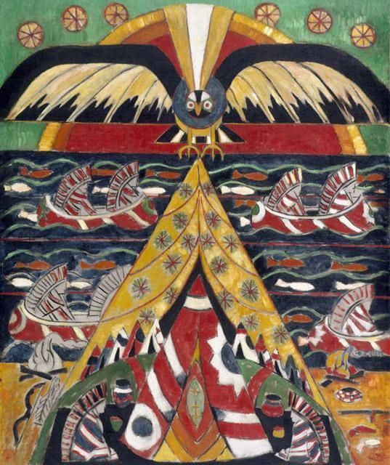
Marsden Hartley, Indian Fantasy, 1914, oil on canvas, 46 11/16 x 39 5/16 in., Purchased with funds from the State of North Carolina

North Carolina Foundations Correlations
Cognitive Development: CD-5, CD-8, CD-11, CD-12

Student Learning Objectives
- Students will learn that Native American cultures respect nature and animals.
- Students will identify repeating patterns in a painting.
- Students will begin to develop an understanding of the painting process.

Activities
Introduction/ Warm-Up

- Introduce Indian Fantasy and discuss some of the things students see. Then, ask: What seems to be the most important thing in the picture? What makes you say that? Discuss.
- Explain that Native Americans were the first peoples to live in this country.
- Point out that the Native Americans in this painting are wearing headdresses made of eagle feathers.
- Explain that Native Americans think all animals are very important. Ask students to point out the animals in the painting and talk about which (if any) are important to them, too.
- Transition to talking about the shapes and patterns students see in the painting. What colors, animals, and shapes repeat?
- Invite students to move their arms like the wavy lines in the water. Have them move like the zigzagging lines on the teepee.
- Transition to discussion about activity. Tell students they will be making their own paintings with patterns.

Focus Activity Procedure
*Note: The paper can be oriented either horizontally or vertically for this project.

- Using a black marker, demonstrate drawing different types of lines and shapes in a pattern on paper. Draw wavy lines, zigzag lines, straight lines, and dotted lines. Have students practice drawing these different types of lines with their finger in the air.
- Next, ask students to suggest a favorite animal to draw in between the lines. *If drawing animals is too difficult for your students, suggest drawing shapes instead. For example, you might draw another pattern of animals (or shapes) in between the wavy and zigzag lines, like the pattern of fish in Indian Fantasy.
- Demonstrate painting the pattern with tempera. Explain to students that they should use a lot of water and a little paint, so that you can see the black lines through the paint. Ask the class: Which colors are repeated?
- Excuse students to their seats to write their name on their paper and get to work. Instruct them to make a pattern that repeats a certain type of line and a favorite animal.
- Circulate throughout class to help students. Make sure student names are legible and if not, write their names clearly.

Closing

- Clean up.
- Gather class together for closing conversation about the paintings they have made. Share artwork. How do your paintings look different from Indian Fantasy? How do they look similar? What patterns did you include? How do those compare to those in Indian Fantasy? Did you include animals or shapes in your painting? If it is too wet to hold up, do a gallery walk around the tables.
- Ask students to look for art all around them at home and at school!

Assessments
- The closing discussion may be used to assess students’ understanding about Native American cultures and their respect for nature and animals.
- Assess if students were able to identify repeating patterns in their own artwork and in Indian Fantasy through observation and discussion of the work.
- Assess students’ ability to follow the artistic process by observing the steps they take as they complete their work and by reviewing their final painting.

Resources

Vocabulary:

Native American
nature

Materials:
11 x 15” sheets watercolor paper, nontoxic Sharpie markers, nontoxic tempera cakes, paintbrushes, cups for water, paper towels

Lesson Resources:

Extension Activities for Teachers
- Ask class to point out patterns they see in their room and when walking around the school campus.
- Study Native American history in class.

Extension Activities for Families

- Visit an N.C. Native American historic site such as Town Creek Indian Mound. Visit the N.C. History Museum. Share a book about Native Americans and early European settlers--possibly about Thanksgiving.
- Talk about different kinds of birds, especially common N.C. birds like cardinals, robins, crows, sparrows. etc. Visit the aviary at the N.C. Zoo. Look at pictures of birds in books. Talk about their names, colors, and size.
- Visit the NCMA and look at the Audubon prints. Visit the N.C. Natural Science Museum and look at birds.

Suggested Books for Classroom Library

Brocket, Jane. Spotty, Stripy, Swirly: What Are Patterns? Millbrook, 2012. [ISBN 978-0-7613-4613-5]

Bryan, Ashley. Beautiful Blackbird. Simon/Atheneum, 2003. [ISBN 978-0-689-84731-8]

Chocolate, Deborah M. Newton. Kente Colors. Illustrations by John Ward. Walker, 1997. [ISBN 978-1-41312-866-6]

Ehlert, Lois. Feathers for Lunch. Harcourt, 1990. [ISBN 978-0-15-230550-5]

Ehlert, Lois. Lots of Spots. Simon/Beach Lane, 2010. [ISBN 973-1-44240-289-8]

Kuskowski, Alex. Super Simple African Art: Fun and Easy Art from around the World. ABDO, 2012. [ISBN 973-1-61783-210-9]

Morris, Ann. Hats, Hats, Hats. Photographs by Ken Heyman. Lothrop, 1989. [ISBN 978-0-688-06338-2]

Pluckrose, Henry Arthur. Pattern. Childrens Press, 1995, 1994. [ISBN 973-0-329-56924-2]

Swinburne, Stephen R. Lots and Lots of Zebra Stripes: Patterns in Nature. Boyds Mills, 2001, 1998. [ISBN 978-0-329-59955-3]

Examples of Successful Student Outcomes
