
www.artnc.org

Self-Portraits

Writer: Andrea Saenz Williams
Grade Level: Pre-K
Related Big Picture Concepts: Identity, Observation
Subject Areas: Visual Arts, Social Studies, Math, Language Arts

Duration: 30 Min.
Essential Question: What is a portrait?

Abstract: Students will explore the concept of portraiture by looking closely at a presidential portrait. They will create a self-portrait to record the way they see themselves.


Pre-K content is made possible by the support of:

Focus Work of Art:
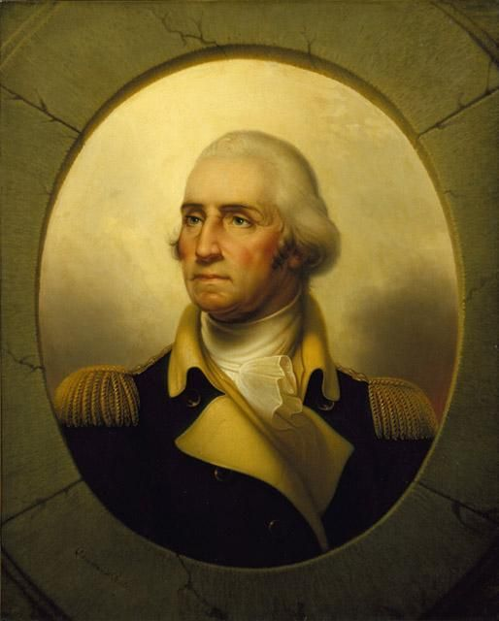
Rembrandt Peale, George Washington (1732–1799), circa 1855, oil on canvas, 36 x 29 in., Gift of Mrs. Charles Lee Smith Sr., William Oliver Smith, Charles Lee Smith Jr., and Mrs. Joseph H. Hardison, in memory of Dr. Charles Lee Smith Sr.

North Carolina Foundations Correlations
Cognitive Development: CD-4, CD-5, CD-8, CD-12
Language Development and Communication: LDC-7

Student Learning Objectives
- Students will understand that a portrait is a picture of a person made by an artist.
- Students will understand that a self-portrait is a picture that someone makes of himself or herself.
- Students will identify eyes, hair, and skin tone and practice proper placement and representation of these features.
- Students will learn that important people in history, such as the president of the United States, have had their portraits painted.

Activities
Introduction/ Warm-Up

- Can anyone tell me the name of the president of the United States? What is a president?
- All of our presidents, from the very first one, have had a portrait made so that people will always be able to remember what they looked like. Show some of the examples of presidential portraits. [http://www.npg.si.edu/exh/travpres/index6.htm] Have students say the word portrait and repeat its definition.
- Introduce George Washington. So many people wanted a portrait by this artist of our first president that he made many paintings like this. He had to practice and practice to get the shape of the eyes and nose and mouth just right so that it really looked like George Washington every time.
- Look closely at the painting and discuss the color of Washington’s eyes, hair, skin, and clothes.
- Transition to the activity by explaining that students are important, just like the president, and they will be making portraits of themselves to record how they see themselves at this age. This type of painting is a called a self-portrait because it is a portrait of themselves made by themselves.

Focus Activity Procedure

- Students go to tables and look in mirrors. Explain that artists first have to observe what a person looks like before they begin painting. Ask about the shape of face, color of eyes, etc. as they look in mirrors. Have students look at a partner at the table. Are their eyes the same color, hair, etc.? (Refer back to mirror to check).
- Pass out pastels after children have completed this self-observation/comparison.
- Have them begin by drawing the shape of their head. They should try to draw a big oval so there will be room for the features. Talk about where the eyes are located. At the top of the head? No. They are about in the middle. Look in the mirror. Are the eyes just one color?
- Draw nose next, then mouth.
- What else needs to be added? (ears, eyebrows, eyelashes if they feel like it, some may add cheeks)
- Have them observe hair: is it straight, curly, short, long? Try to make it look like your hair really looks.
- Are there any other details you would like to add? (Some girls may have earrings or hair bows or clips, etc. that they want to add.)
- What color clothes would you like to have for your portrait? What is your favorite color?
- Students should sign their own work on the front in pastel. Teachers can assist.
- Before students do gallery walk, prompt them to look at each other’s work for differences in hair color, eye color, and favorite colors chosen for clothing.

Closing

- Clean up by placing pastels back in container.
- Leave portraits on tables and do a gallery walk. As class looks at portraits, ask students how they are different from the portrait of George Washington. Who was George Washington? Why do we have a portrait of him today? How is your picture the same as his? How is it different? Ask for a show of hands to see who would like to draw a portrait of someone else. Ask for volunteers to say who they would like to draw. Is that person a family member? Is he or she famous?
- Ask students to look for art all around them at home and at school!

Assessments
- During closing discussion, check for student understanding of the terms portrait/self-portrait and student ability to identify similarities/differences between themselves and George Washington.
- While students are working, observe where they are placing their features on their paper. Are they approximately in the correct spot? Are the students observing themselves carefully in the mirror while drawing? Are they including all of their features, or just some?

Resources

Vocabulary:

portrait
self-portrait
Features: eyes, nose, mouth, eyebrows, eyelashes, ears
hairstyle
oval
details
pastel
chalk

Materials:
Teacher materials
Images of United States presidents

Student materials
9 x 12” drawing paper, chalk pastels, plexiglass mirrors

Set up:
Place mirrors on tables.
Paper on tables.
Containers of chalk after students have finished observation exercise.

Lesson Resources:

Extension Activities for Teachers
- Talk to your students about the presidents of the United States.
- Talk to your students about school portraits and family portraits.
- Look at photos of United States presidents in books or online; notice whether they have long or short hair, beards, mustaches, etc.
- Encourage students to practice drawing portraits in a sketchbook they make. Students can take turns drawing each other.

Extension Activities for Families
- Look at old family portraits and pictures of family members as children. Compare these portraits to how the student’s family members look today by observing eye color, hair color, shape of face, features, etc. What familial features are the most dominant?

Suggested Books for the Classroom Library
Pinkney, Sandra L. Shades of Black: A Celebration of Our Children. Photographs by Myles C. Pinkney. Scholastic, 2000. [ISBN 978-0-439-14892-4]

Smith, Charles R. I Am America. Scholastic, 2003. [ISBN 978-0-439-43179-8]

Examples of Successful Student Outcomes
