
www.artnc.org

Torn Collage Portraits

Writer: Andrea Saenz Williams
Grade Level: Pre-K
Related Big Picture Concepts: Change
Subject Areas: Visual Arts, Social Studies, Math, English Language Arts
Duration: 30 min.
Essential Question: How were people’s clothing different long ago?

Abstract: Students will learn to compare and contrast paintings of people who lived in the past and present. Students will create a portrait of a man or woman from long ago using torn paper, embellished with period costume.


Pre-K content is made possible by the support of:

Focus Works of Art:
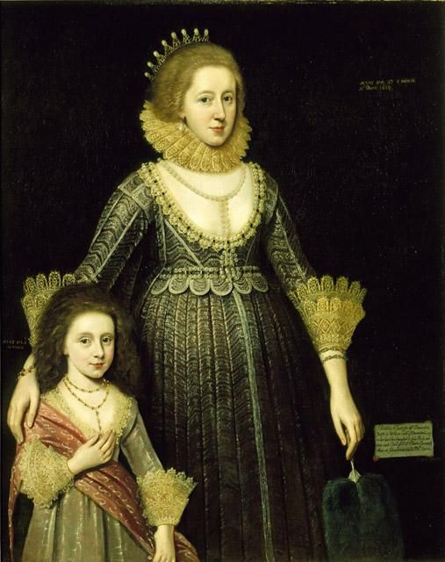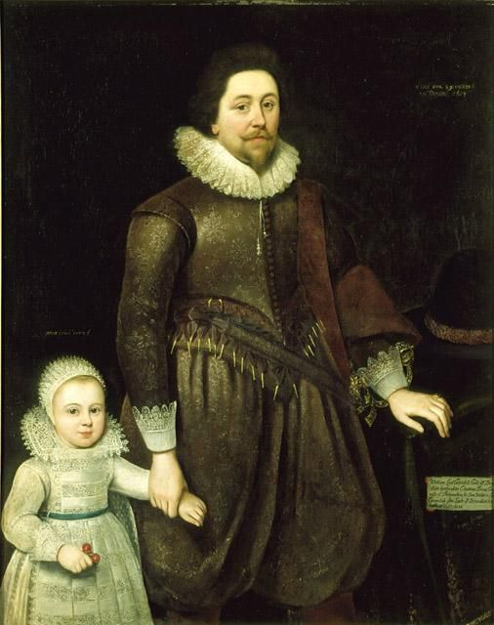
Paul van Somer, Christian, Lady Cavendish, Later Countess of Devonshire (1598– 1675), and Her Daughter, 1619, oil on canvas, 51 1/2 * 41 1/2 in., Gift of Mr. and Mrs. Luther Hartwell Hodges

Paul van Somer, William, Lord Cavendish, Later Second Earl of Devonshire (1591– 1628), and His Son, 1619, oil on canvas, 51 1/2 * 41 1/2 in., Gift of John Motley Morehead

North Carolina Foundations Correlations
Cognitive Development: CD-1, CD-5, CD-8, CD-12
Language Development and Communication: LDC-5

Student Learning Objectives
- Students will compare and contrast portraits of people who lived in the past and who live in the present.
- Students will create a portrait of someone who lived a long time ago, paying close attention to clothing details.
- Students will become more aware of relative position and size and shape of body parts.
- Students will gain greater control with glue application and paper tearing.

Activities
Introduction/ Warm-Up

- Did you have your picture taken at school this year? Have you ever had your picture taken with someone in your family? Show examples of family portraits. Describe the type of clothes people are wearing.
- A long, long time ago there were no photographs. Before the camera was invented, people hired an artist to draw or paint them if they wanted a picture of themselves.
- Introduce the paintings and tell students the paintings were created a long time ago. Ask students to describe the clothing and the figures. How are these people like us? How are they different?
- Tell students they will be making a paper portrait of a person who looks like she or he lived a long time ago. Remind them that clothing is one of the main differences in how people looked then and now. Show some examples of dress from different time periods. Use vocabulary words, such as collar, sleeves, pins, necklace, etc. Have students try on costumes and use the vocabulary words to identify what they are wearing.
- To remind students of all the body parts they will need in their portraits, play Simon Says: Call out body parts and portrait features on the vocabulary list.

Focus Activity Procedure

- Students write names on the back of their papers before beginning.
- Then they will start with head rectangle and tear parts of it to approximate an oval (in advance, teacher may choose to draw ovals for students to tear or cut around as a template).
- Glue the oval to the background paper; then glue the neck to the head (both flesh colored).
- Give students a choice of blue or black for shoulders. Have them glue that to the neck and background.
- Add lace where it belongs. Tear to make pieces (neck and cuffs) (use dots of glue).
- Add hair from scraps (use dots of glue) or draw with crayons.
- Add features from scraps or draw with crayons.
- Students can add other costume details, such as jewelry with
metallic paper scraps or crayons.
- Optional, if time allows: Tear arms and hands from flesh colored
construction paper and glue to extend from background.

Closing

- Clean up.
- Close glue bottles.
- Pick up paper scraps.
- Ask students to raise hands in response to questions to the group about their portraits: How many have lace on their portrait? How many put jewels on their person? How many of you chose black for the clothing? How many chose blue? How many have black hair, brown hair, yellow hair, red hair, etc.
- Ask students to look for art all around them at home and at school!

Assessments
- Take a poll of the students in the class asking who would like to wear the clothing from the portraits and who would like to wear the clothing they wear today. Ask students to provide reasons to back up their decisions to assess their understanding.
- Observe students as they create their portraits. Are they tearing paper or cutting? Does their portrait have facial features in the correct place or approximately the correct place?

Resources

Vocabulary:

portrait
lace
oval
circle
head
neck
shoulders
arms
hands
photograph
invent
Features: eyes, nose, mouth, eyebrows, etc.

Materials:
Family portraits (photographs of students’ families), photographs of people from different time periods that show what they wore, construction paper in a wide range of flesh tones, black and blue, scraps in yellow, brown, black, red, 12 x 18” construction paper (for background), nontoxic crayon, 1/2 paper lace doily per child, Elmer’s glue, small amount of metallic paper scraps

Lesson Resources:

Extension Activities for Teachers

- Discuss with class clothing preferences and how people dressed differently during different time periods. Set up costumes in the dramatic play area for children to try. Take a poll to see what type of clothing students prefer.

Extension Activities for Families

- Get out old photographs of your child or other family members. Talk about what their/your favorite clothing was at a particular age/time. Talk about special clothing for different activities, such as sports, place of worship, a wedding, etc.
- Come to the North Carolina Museum of Art and look at the portraits of people from long ago in their beautiful clothing and jewels.

Suggested Books for Classroom Library

Ajmera, Maya, Elise Hofer Derstine, and Cynthia Pon. What We Wear: Dressing Up Around the World. Charlesbridge, 2012. [ISBN 978-1-58089-416-6]

Brent, Lynnette R. At Play: Long Ago and Today. Heinemann Library, 2003. [ISBN 978-1-40344-538-4]

Brent, Lynnette R. At Work: Long Ago and Today. Heinemann Library, 2003. [ISBN 978-1-40344-542-1]

Doudna, Kelly. Clothing Around the World. ABDO, 2004. [ISBN 978-1-59197-565-6]

Examples of Successful Student Outcomes
