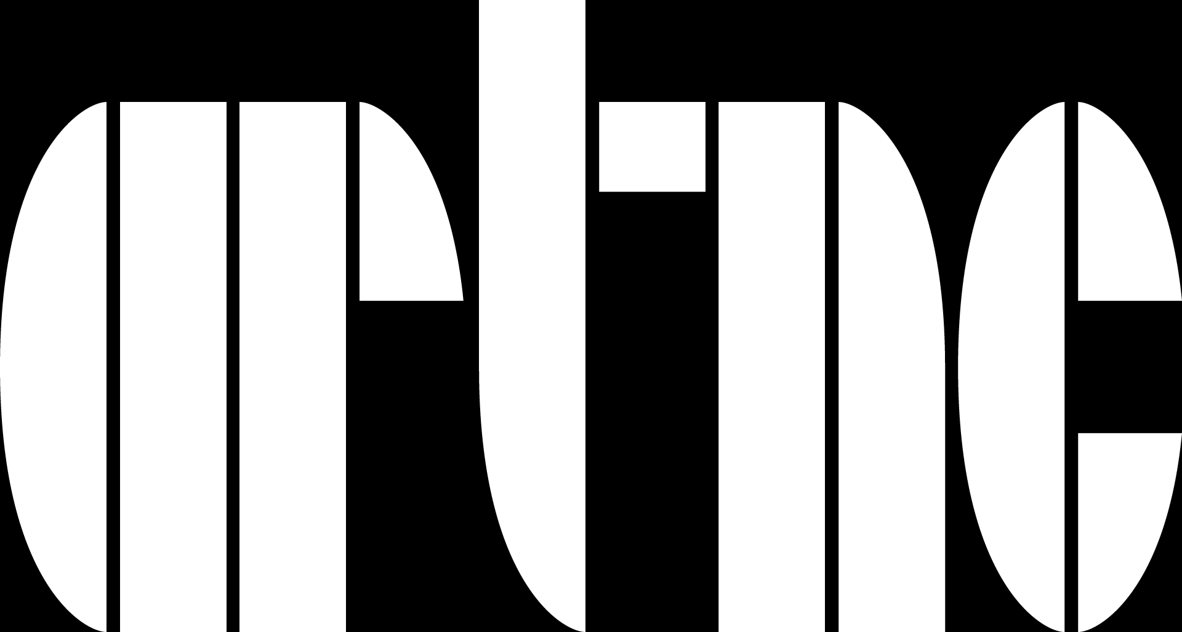
www.artnc.org

Using Symbols

Writer: Sarah Fink, elementary educator
Grade Level: K-1
Related Big Picture Concept: Survival
Subject Areas: Visual Arts, Social Studies
Essential Question: How do we use symbols to represent needs?
Abstract: Students will read a book about needs and wants, discuss basic needs, observe Egyptian symbols representing basic needs, and create their own ‘vacation list’ using symbols to represent their basic needs.
Duration: 45 minutes

Focus Works of Art:
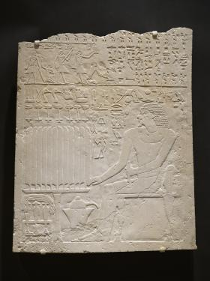
Egyptian
possibly from Saqqara
Relief from the Tomb of Khnumti 1
Old Kingdom, Dynasty VI, circa 2345-2184 B.C.E.
White limestone
23 7/8 x 19 5/8 x 1 in. (60.6 x 49.8 x 2.5 cm)
Gift of the James G. Hanes Memorial Fund

North Carolina Standards Correlations
Visual Arts:
K.V.1.1, K.V.1.3, K.CX. 1.5, K.CX.2.1, K.CX.2.2, 1.V.1.2, 1.V.1.3, 1.CX.1.1, 1.CX.1.5, 1.CX.2.2

Subject: Social Studies
K.G.2.2, 1.G.2.2

Student Learning Objectives
- Students will be able to define needs and wants.
- Students will be able to classify needs and wants by explaining the reasons a specific item is a need or want.
- Students will be able to compare and contrast needs portrayed by ancient Egyptians and their own needs.
- Students will be able to define hieroglyphics as a system of writing using picture symbols to represent sounds or words
- Students will be able to create their own symbols to represent needs and compare those symbols to the symbols of their peers.

Activities
- Ask students to imagine that they are going on an adventure trip for two weeks. They are going to park their car at the entrance to a forest and spend the next two weeks in the woods with no houses or buildings. Brainstorm a list of things their family would need to bring. Keep the list on large chart paper or on the white board so that students can refer to it later in the lesson. Encourage students to break categories down. Rather than ‘food’, ask what kinds of food might be needed. Write ‘fruits,’ ‘vegetables’, and ‘grains’. Write down everything the students mention, even if it is a ‘want’ rather than a ‘need’. Students will edit the list throughout the lesson.
- Read Needs and Wants by Gillia M.Olson. After you have read, ask students to discuss the book. What is the difference between needs and wants? Are there items on the list that were mentioned in the book? Are there things in the book that should be added to the list? Are there ‘wants’ on the list that are not things that a family would need to survive? Add to and cross out items to reflect class discussion. Encourage students to explain reasons they might or might not need items.
- Discuss list making. When do adults make lists for things? Why do we make lists? Give the example of going to the grocery store. We make lists to remember all of the items we need for the week. If we need two bags of apples, we might write a 2 by the word apples. Tell students that people for thousands of years have thought carefully about what they need. Long ago, Egyptians carved symbols into stone for the tombs of people who died. Show students the Relief from the Tomb of Khnumti 1. Observe quietly for two or three minutes. What symbols do you see? What might the symbols represent? Tell students that the Egyptians drew symbols on tombs because they wanted their friends to have everything they needed in the afterlife. What things did the Egyptians think they needed for the afterlife? Some needs represented above the head of Khnumti include bread, cattle, birds, and linen. The line below of repeated plant symbols indicates thousands of these provisions, just like we use numbers to show how many things we need today.
- Tell students that the symbols they see on the tomb are called hieroglyphics. Rather than using letters to write words, ancient Egyptians used pictures to create words. The pictures represented the items the Egyptians needed.
- Again show students the Relief from the Tomb of Khnumti 1. Ask students what they think the tomb relief is made of. Tell them it is stone. Ask them how the hieroglyphics might have been created in the stone. Show them how the symbols pop out of the stone, like a low profile stamp. The artist would have to carefully outline the symbol and then slowly and carefully chip around the outline to make the image pop out of the stone. Today we do not need to carve our lists of needs in stone. We use paper instead. We use words today to make lists, but we also use symbols. Where do we see symbols in our neighborhoods? Examples might include stop signs and crosswalk signs and in a legend on a map.
- Tell students that they are going to look at the list of needs the class created and choose five of the things they would most want to bring on a family trip to the woods and represent those items using symbols. Brainstorm different simple symbol options for each item and draw a symbol next to the word. Tell students they can use the symbols on the list or create their own. Ask students to create a ‘packing list’ of five different needs. If they choose water and think they might need a lot of water, encourage them to show that amount through repetition as they saw in the relief by drawing their symbol for water across their page. Hand out paper and ask students to draw their ‘packing list’ symbols.
- Put packing lists up. What needs are represented on the lists? What symbols are most common? Did anybody create their own symbols? Why might some needs be most represented or popular? How are the symbols similar or different to the hieroglyphic symbols of the Egyptians? Was repetition used in creating the packing lists?

Assessments
Class discussion and creation of the class list will show that students understand the difference between needs and wants and can articulate that difference when crossing off or adding to the list.
Class discussion will show that students are able to identify hieroglyphic symbols for various needs of the Egyptians.
Creation of ‘packing lists’ using symbols will show that students understand that each need is represented by a symbol and that symbols can be used in repetition to represent large amounts.

Resources
Vocabulary:
Needs – Something necessary to live a healthy life.
Wants – Something desired which is not necessary to survive.
Afterlife – the ‘next world’ or life after death
Relief – projection of shapes, symbols, or words from a flat background
Hieroglyphics – a system of writing using picture symbols to represent sounds or words

Materials:
Colored pencils
Paper

Lesson Resources:
Needs and Wants by Gillia M.Olson
The Bag I’m Taking to Grandma’s by Shirley Neitzel (optional text)

http://artnc.org/works-of-art/relief-tomb-khnumti-1

